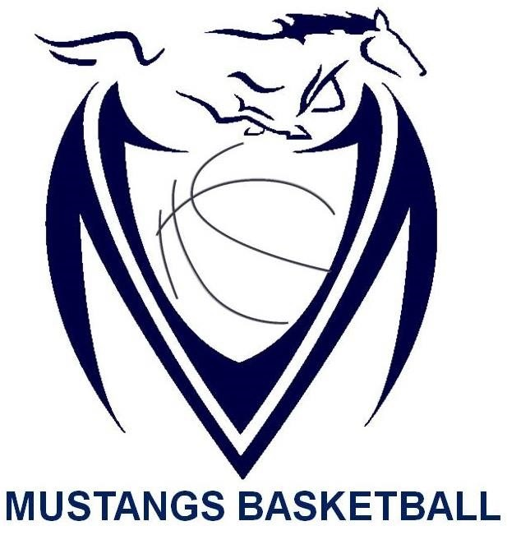

Massey Mustangs 2016-17
Junior Boys ROSTER
Name | Grade | Position | Height
Amjed Alghizi | 10 | Guard | 5 ‘ 10 “
Nyles Duren | 10 | Guard | 6 ‘ 2 “
Ahad Khan | 10 | Guard | 6 ‘ 0 “
Hamza Mohamed | 10 | Guard | 5 ‘ 10 “
Tail Wang | 10 | Guard | 6 ‘ 1 “
Noah Kovach | 10 | Forward | 6 ‘ 4 “
Nate Norton | 10 | Forward | 6 ‘ 0 “
Chandler Palko | 10 | Forward | 6 ‘ 2 “
Chirag Rampure | 10 | Forward | 6 ‘ 1 “
Ajay Sandhu | 10 | Forward | 6 ‘ 5 “
Deepen Sharma | 10 | Forward | 6 ‘ 3 “
Ryan Ngo | 9 | Guard | 6 ‘ 0 “
Salah Hersr | 9 | Forward | 6 ‘ 3 “

Coaching Staff:

Chris Thomson | 16th Year as (Head Coach for Massey Basketball)
Shehram Khan | 1st Year as (Assistant Coach ; Teacher Sponsor for Massey Basketball)

