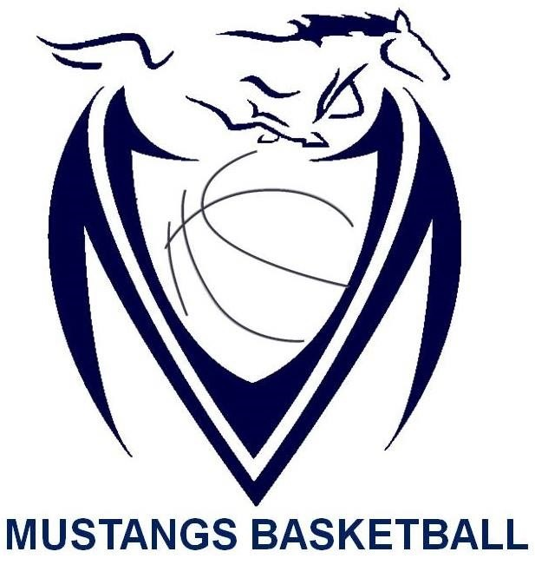

Massey Mustangs 2017-18
B-Team Boys ROSTER
Name | Grade
Hadad Ahmad | 10
Jad Aswad | 10
Aryan Fard | 10
Adam Ghadban | 10
Ahmad Munim | 10
Husnain Raja | 10
Rajan Singh | 10
Colin Hendry | 9
Sabir Jama | 9
Samir Jama | 9
Noah Lucier | 9
Jaiden Nuckles | 9

Coaching Staff:

Omar Hayes-Williams | 3rd Year as (Head Coach for Massey Basketball)
Marko Saric | 3rd Year as (Head Coach for Massey Basketball)
Michael Grouix | 1st Year as (Teacher Sponsor)

