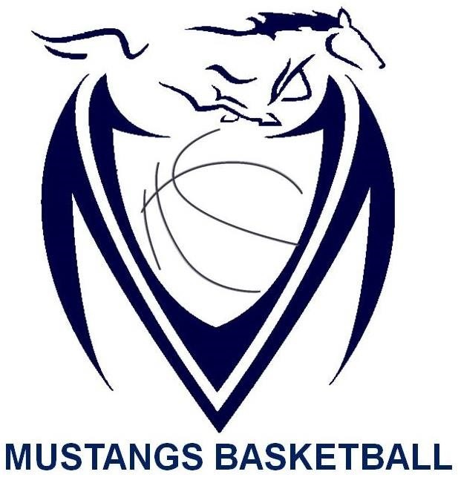

Massey Mustangs 2019-20
Senior Boys SCHEDULE
Date | Time | Opponent | Location | Type of Game
Nov. 29th | TBA | TBA | Catholic Central | 2019 Freeds Tip Off Tournament
Nov. 29th | TBA | TBA | Catholic Central | 2019 Freeds Tip Off Tournament
Nov. 30th | TBA | TBA | Catholic Central | 2019 Freeds Tip Off Tournament
Dec. 5th | 4:00pm | Assumption | Massey | WECSAA
Dec. 10th | 5:30pm | L’Essor | L’Essor | WECSSAA
Dec. 12th | 4:00pm | Lamothe-Cadillac | Massey | WECSSAA
Dec. 17th | 5:30pm | Kingsville | Kingsville | WECSSAA
Jan. 9th | 4:00pm | Sandwich | Sandwich | WECSSAA
Jan. 10th | TBA | TBA | Massey | 2020 Senior Mustangs Classic Tournament
Jan. 11th | TBA | TBA | Massey | 2020 Senior Mustangs Classic Tournament
Jan. 14th | 5:30pm | General Amherst | General Amherst | WECSSAA
Jan. 20th | 5:30pm | Walkerville | Massey | WECSSAA
Jan. 31st | TBA | TBA | Riverside | 2020 Senior Rebels Classic Tournament
Feb. 1st | TBA | TBA | Riverside | 2020 Senior Rebels Classic Tournament
Feb. 4th | 5:30pm | Leamington | Leamington | WECSSAA
Feb. 6th | 4:00pm | Essex | Massey | WECSSAA
Feb. 12th | TBA | TBA | TBA | WECSSAA Quarter Finals
Feb. 14th | TBA | TBA | TBA | WECSSAA Semi Finals
Feb. 16th | TBA | TBA | St. Clair College | WECSSAA Championships
Feb. 26th | TBA | TBA | Windsor | SWOSSAA Championships
Mar. 9th | TBA | TBA | Burlington | AAA OFSAA 2020
Mar. 10th | TBA | TBA | Burlington | AAA OFSAA 2020
Mar. 11th | TBA | TBA | Burlington | AAA OFSAA 2020

