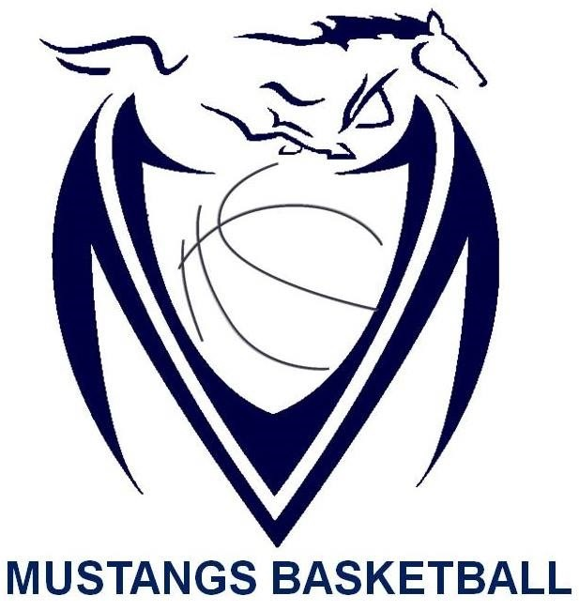

Massey Mustangs 2017-18
Senior Boys SCHEDULE

Date | Time | Opponent | Location | Type of Game
Nov. 23rd | 12:00pm | London Montcalm | Kennedy | 2017 Kennedy Clippers Classic Tournament
Nov. 23rd | 5:00pm/6:30 pm | Kennedy/London Sir Wilfred Laurier | Kennedy | 2017 Kennedy Clippers Classic  Tournament
Nov. 24th | TBA | TBA | Kennedy | 2017 Kennedy Clippers Classic  Tournament
Nov. 29th | 3:30pm | St. Joseph | Massey | Pre-Season
Dec. 7th | 5:30pm | Kennedy | Massey | WECSSAA
Dec. 12th | 7:00pm | Herman | Herman | WECSSAA
Dec. 14th | 5:30pm | Holy Names | Massey | WECSSAA
Dec. 19th | 5:30pm | Lajeunesse | Massey | WECSSAA
Jan. 9th | 5:30pm | Sandwich | Massey | WECSSAA
Jan. 11th | 5:30pm | St. Annes | St. Annes | WECSSAA
Jan. 12th | TBA | TBA | Massey | 2018 Senior Mustangs Classic Tournament
Jan. 13th | TBA | TBA | Massey | 2018 Senior Mustangs Classic Tournament
Jan. 18th | 5:30pm | Riverside | Riverside | WECSSAA
Jan. 22nd | 5:30pm | Catholic Central | Massey | WECSSAA
Feb. 2nd | TBA | TBA | Riverside | 2018 Riverside Rebels Classic Tournament
Feb. 3rd | TBA | TBA | Riverside | 2018 Riverside Rebels Classic Tournament
Feb 6th | 7:00pm | Holy Names | Holy Names | WECSSAA
Feb 8th | 5:30pm | Assumption | Assumption | WECSSAA
TBA | TBA | TBA | TBA | WECSSAA Quarter Finals
TBA | TBA | TBA | TBA | WECSSAA Semi Finals
Feb. 18th | TBA | TBA | U of W St. Denis Center | WECSSAA Championships
Feb. 22nd | TBA | TBA | Massey | SWOSSAA Championships
Mar. 5th | TBA | TBA | Windsor | AAA OFSAA 2018
Mar. 6th | TBA | TBA | Windsor | AAA OFSAA 2018
Mar. 7th | TBA | TBA | Windsor | AAA OFSAA 2018

