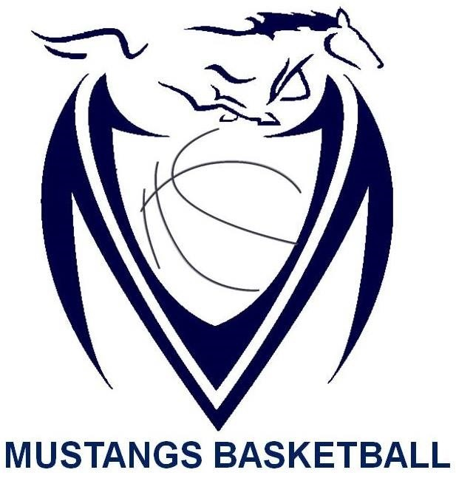

Massey Mustangs 2017-18
Junior Boys SCHEDULE

Date | Time | Opponent | Location | Type of Game
Nov. 29th | 3:45pm | Lamothe-Cadillac | Lamothe-Cadillac | Pre-Season
Dec. 1st | 4:30pm | Leamington | L'Essor | 2017 L’Essor Pepsi Challenge Tournament
Dec. 2nd | 9:00am/12:00pm | Essex/Belle River | L’Essor | 2017 L’Essor Pepsi Challenge Tournament
Dec. 2nd | TBA | TBA | L’Essor | 2017 L’Essor Pepsi Challenge Tournament
Dec. 7th | 4:00pm | Kennedy | Massey | WECSSAA
Dec. 8th | TBA | TBA | Riverside | 2017 Riverside Rebels Classic Tournament
Dec. 9th | TBA | TBA | Riverside | 2017 Riverside Rebels Classic Tournament
Dec. 12th | 5:30pm | Herman | Herman | WECSSAA
Dec. 14th | 4:00pm | Holy Names | Massey | WECSSAA
Dec. 19th | 4:00pm | Lajeunesse | Massey | WECSSAA
Jan. 9th | 4:00pm | Sandwich | Massey | WECSSAA
Jan. 11th | 4:00pm | St. Annes | St. Annes | WECSSAA
Jan. 18th | 4:00pm | Riverside | Riverside | WECSSAA
Jan. 19th | TBA | TBA | Massey | 2018 Junior Mustangs Classic Tournament
Jan. 20th | TBA | TBA | Massey | 2018 Junior Mustangs Classic Tournament
Jan. 22nd | 4:00pm | Catholic Central | Massey | WECSSAA
Feb. 6th | 5:30pm | Holy Names | Holy Names | WECSSAA
Feb. 8th | 4:00pm | Assumption | Assumption | WECSSAA
TBA | TBA | TBA | TBA | WECSSAA Quarter Finals
TBA | TBA | TBA | TBA | WECSSAA Semi Finals
Feb. 18th | TBA | TBA | U of W St. Denis Center | WECSSAA Championships
Feb. 23rd | TBA | TBA | Sarnia/Lambton Kent | SWOSSAA Championships
TBA | TBA | TBA | Unionville | Ontario JBC Championships
TBA | TBA | TBA | Unionville | Ontario JBC Championships
TBA | TBA | TBA | Unionville | Ontario JBC Championships

