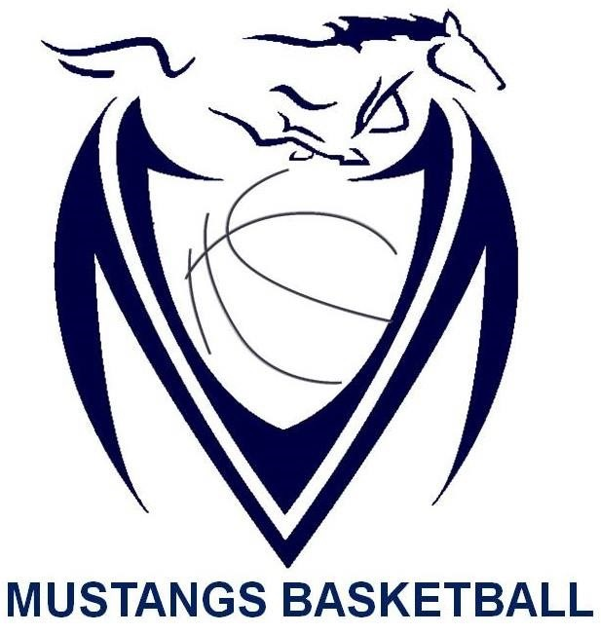

Massey Mustangs 2016-17
Junior Boys SCHEDULE
Date | Time | Opponent | Location | Type of Game
Dec. 6th | 4:00pm | Brennan | Brennan | Pre-Season
Dec. 8th | 4:00pm | St. Joseph | Massey | WECSSAA
Dec. 9th | TBA | TBA | TBA | 2016 Riverside Jr. Rebels Classic Tournament
Dec. 10th | TBA | TBA | TBA | 2016 Riverside Jr. Rebels Classic Tournament
Dec. 13th | 4:00pm | Assumption | Massey | WECSSAA
Dec. 15th | 4:00pm | St. Annes | Massey | WECSSAA
Dec. 20th | 4:00pm | Lajeunesse | Lajeunesse | WECSSAA
Jan. 10th | 4:00pm | Sandwich | Sandwich | WECSSAA
Jan. 12th | 4:00pm | Riverside | Massey | WECSSAA
Jan. 17th | 5:30pm | Kennedy | Kennedy | WECSSAA
Jan 20th | TBA | TBA | Massey | 2017 Junior Mustangs Classic Tournament
Jan 21st | TBA | TBA | Massey | 2017 Junior Mustangs Classic Tournament
Jan. 23rd | 4:00pm | Catholic Central | Catholic Central | WECSSAA
Feb. 2nd | 5:15pm | Herman | Massey | WECSSAA
Feb. 7th | 5:15 pm | Holy Names | Holy Names | WECSSAA
Feb. 10th | TBA | TBA | TBA | WECSSAA Quarter Finals
Feb. 15th | TBA | TBA | TBA | WECSSAA Semi Finals
Feb. 19th | TBA | TBA | U of W St. Denis Center | WECSSAA Championships
Feb. 23rd | TBA | TBA | Windsor | SWOSSAA Championships
TBA | TBA | TBA | Unionville , ON | Ontario JBC 2017
TBA | TBA | TBA | Unionville , ON | Ontario JBC 2017
TBA | TBA | TBA | Unionville , ON | Ontario JBC 2017

