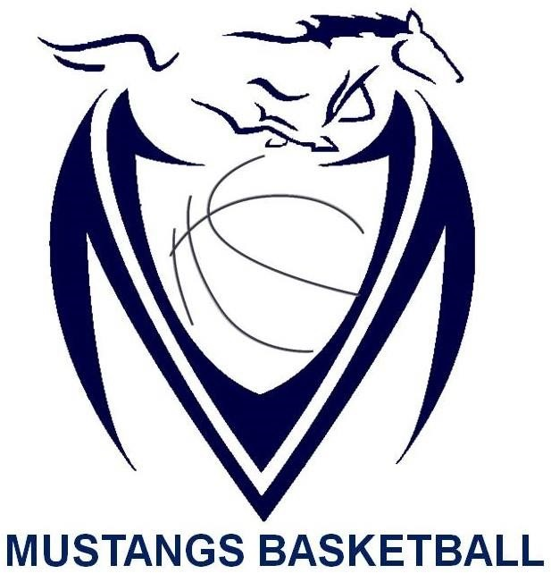

Massey Mustangs 2016-17
Senior Boys ROSTER
Name | Grade | Position | Height
Dren Ibrahimi | 13 | Guard | 5 ‘ 9 “
Ali Sayed-Ali | 12 | Guard | 5 ‘ 11 “
Jerry Mungwarere | 12 | Guard | 6 ‘ 1 “
Dylan Samuels | 12 | Guard | 6 ‘ 2 “
Tyler D’Amore | 12 | Forward | 6‘ 1 “
Ugo Madu | 12 | Forward | 6 ‘ 2 “
Adam Youssef | 12 | Forward | 6 ‘ 0 “
Filip Vucak | 11 | Guard | 6 ‘ 3 “
Ibraheem Aloran | 11 | Guard | 5 ‘ 8 “
Jared Hayes-Williams | 11 | Guard | 6 ‘ 2 “
Manroop Gill | 11 | Guard | 5 ‘ 11 “
Sean Mei | 11 | Guard | 6 ‘ 2 “
Abdallah Awada | 11 | Guard | 6 ‘ 1 “

Coaching Staff:

Keith McShan | 4th Year as (Head Coach for Massey Basketball)
Cole Desjardins | 1st Year as (Assistant Coach ; Teacher Sponsor for Massey Basketball)
Mr. Nick Cruise | 1st Year as (Teacher Sponsor for Massey Basketball)

Managerial Staff:

Jackie Kam | 4th Year as (Media Relations for Massey Basketball )
David Oteng-Pabi | 1sty Year as (Statistician for Massey Basketball)

