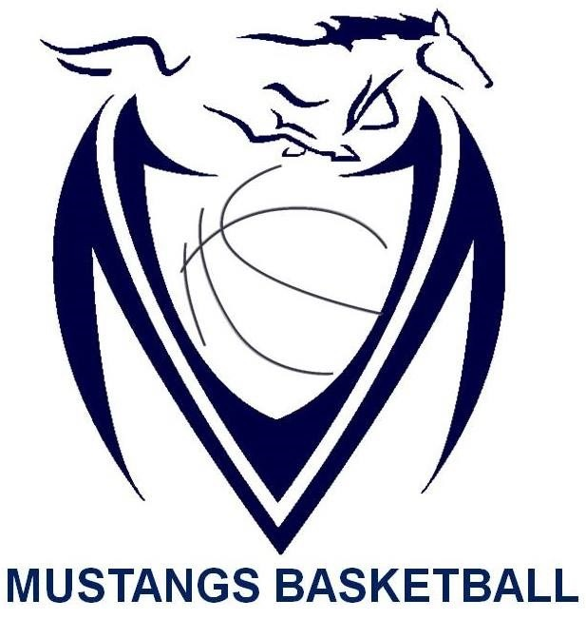

Massey Mustangs 2016-17
Senior Boys SCHEDULE
Date | Time | Opponent | Location | Type of Game
Nov. 25th | TBA | TBA | St. Clair College | 2016 Freeds Tournament
Nov. 26th | TBA | TBA | St. Clair College | 2016 Freeds Tournament
Dec. 2nd | TBA | TBA | Chatham | Sports Hall of Fame Tournament
Dec. 3rd | TBA | TBA | Chatham | Sports Hall of Fame Tournament
Dec. 6th | 5:45pm | Brennan | Brennan | Exhibition
Dec. 8th | 5:45pm | St. Joseph | Massey | WECSSAA
Dec. 9th | TBA | TBA | L’Essor | 2016 9th Annual Robbie Jones Memorial Tournament (L’Essor)
Dec. 10th | TBA | TBA | L’Essor | 2016 9th Annual Robbie Jones Memorial Tournament (L’Essor)
Dec. 13th | 5:45pm | Assumption | Massey | WECSSAA
Dec. 15th | 5:45pm | St. Annes | Massey | WECSSAA
Dec. 20th | 5:45pm | Lajeunesse | Lajeunesse | WECSSAA
Jan. 10th | 5:45pm | Sandwich | Sandwich | WECSSAA
Jan. 12th | 5:45pm | Riverside | Massey | WECSSAA
Jan. 13th | TBA | TBA | Massey | 2017 Senior Mustangs Classic Tournament
Jan. 14th | TBA | TBA | Massey | 2017 Senior Mustangs Classic Tournament
Jan. 17th | 7:00pm | Kennedy | Kennedy | WECSSAA
Jan. 23rd | 5:45pm | Catholic Central | Catholic Central | WECSSAA
Feb. 2nd | 7:00pm | Herman | Massey | WECSSAA
Feb. 3rd | TBA | TBA | Riverside | 2017 Riverside Rebels Classic Tournament
Feb. 4th | TBA | TBA | Riverside | 2017 Riverside Rebels Classic Tournament
Feb 7th | 7:00pm | Holy Names | Holy Names | WECSSAA
TBA | TBA | TBA | TBA | WECSSAA Quarter Finals
TBA | TBA | TBA | TBA | WECSSAA Semi Finals
TBA | TBA | TBA | U of W St. Denis Center | WECSSAA Championships
Feb. 22nd | TBA | TBA | Lambton Kent/Sarnia | SWOSSAA Championships
Mar. 6th | TBA | TBA | North Bay | AAA OFSAA 2017
Mar. 7th | TBA | TBA | North Bay | AAA OFSAA 2017
Mar. 8th | TBA | TBA | North Bay | AAA OFSAA 2017

